MVVM Architecture:

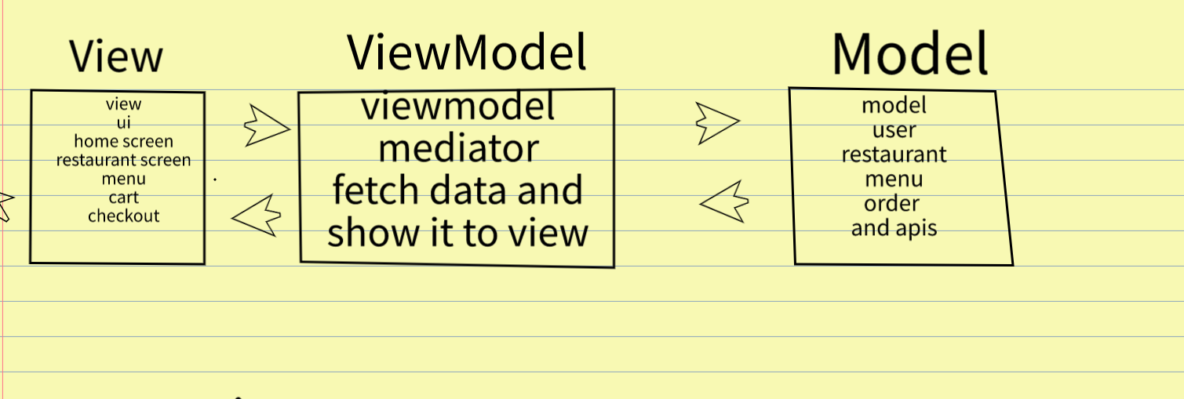

**MVVM** is called as Model-View-ViewModel . It is an architecture used in the development.

It contains 3 parts:

**1] View-** It is one of component used as the frontend.It is used to represent the data or view the data. It is an UI interface.

E.g. As above in fig the view contains the home screen, restaurant screen, menu, cart which is visuals is a view. It shows the all data from the model.

**2] ViewModel-** It act like one of the mediator among the View and Model. It fetch the data from the Model and pass it to the View.

**3] Model-** It is the backend. It is used to store the all data. Here the all information of each model is stored and the API’s also available in the Model.

E.g. In the fig as shown the all the information of the users, restaurants, menu, orders is stored in the model.

It store all the data and perform as backend of mvvm.

In this way the MVVM architecture works and helpul in the development